EXERCISE 14 REACTJS-HOL

Explain the Need and Benefits of React Context API
The React Context API is a built-in solution for managing global state or data that needs to be accessible across multiple components, without the need to pass props manually at every level (known as "prop drilling"). It is especially useful for data like authentication status, user preferences, themes, or language settings.
Benefits include:
- Avoids prop drilling by sharing values directly between components, no matter how deeply nested.
- Makes code cleaner and more maintainable.
- Great for global data access in medium to large-scale applications.
- Works well with React's component re-rendering and performance optimization techniques.

Working with createContext()
To use the React Context API, you start by creating a context using the createContext() function:
const MyContext = React.createContext();
This creates a Context object. Next, you use a Provider to wrap the component tree and pass the shared value:
<MyContext.Provider value={/* some value */}>
<App />
</MyContext.Provider>
Any nested component can now consume the context value using useContext(MyContext) hook:
const value = useContext(MyContext);
Alternatively, in class components, you can use <MyContext.Consumer>.

List the Types of Router Components
In React Router, there are several key types of router components used for navigation and route configuration:
- BrowserRouter
  - Uses the HTML5 history API (pushState, popState) for clean URLs.
  - Example:
  - <BrowserRouter>...</BrowserRouter>
- HashRouter
  - Uses URL hash (#) for routing.
  - Useful when the server does not support direct URL handling.
  - Example:
  - <HashRouter>...</HashRouter>
- Routes
  - Used to wrap multiple Route components and match the best route.
  - Example:
  - <Routes>
  - <Route path="/" element={<Home />} />
  - </Routes>
- Route
  - Used to define a path and the corresponding component to render.
  - Example:
  - <Route path="/about" element={<About />} />
- Link
  - Used for client-side navigation without page reload.
  - Example:
  - <Link to="/about">About</Link>
- NavLink
  - Similar to Link but provides styling based on the active route.
  - Useful for navigation menus.
- useNavigate
  - A hook used for programmatic navigation inside function components.

HANDS-ON EXERCISE:
STRUCTURE:
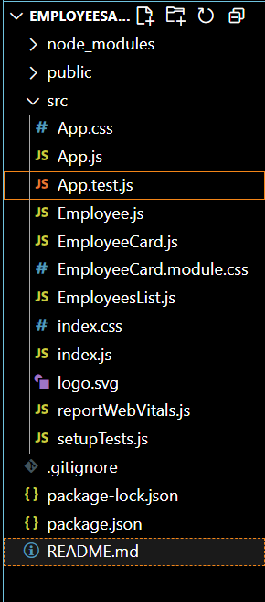

CODE:
App.js
import logo from './logo.svg';
import './App.css';
import { EmployeesData } from './Employee';
import EmployeesList from './EmployeesList';
import { useState } from 'react';
function App() {
const Employees = EmployeesData;
const [theme, setTheme] = useState('light');
return (
<>
<div>
<label>SELECT A THEME </label>
<select onChange={(e) => setTheme(e.target.value)}>
<option value='light'>Light</option>
<option value='dark'>Dark</option>
</select>

</div>
<EmployeesList theme={theme} employees={Employees} />
</>
);
}

export default App;

Employee.js
class Employee {
constructor(id, name, email, phone){
this.id=id;
this.name=name;
this.email=email;
this.phone=phone;
}
}

const EmployeesData=[
new Employee(101,'Jojo','jojo@congizant.com','98238971234'),
new Employee(102,'Sam','sam@congizant.com', '9981184126'),
new Employee(103,'Elisa','elisa@cognizant.com','9989389735')
];

export default Employee;
export {EmployeesData};

EmployeeCard.js
import Styles from './EmployeeCard.module.css';
function EmployeeCard(props) {
return (
<div className={Styles.Card}>
<h3>{props.employee.name}</h3>
<p>{props.employee.email}</p>
<p>{props.employee.phone}</p>
<p>
<a href="#" className={props.theme}>Edit</a>
<a href="#" className={props.theme}>Delete</a>
</p>
</div>
);
}
export default EmployeeCard;

EmployeesList.js
import EmployeeCard from './EmployeeCard';
function EmployeesList(props) {
return (
<div>
<h1>Employees List</h1>
{
props.employees.map(employee =>
<EmployeeCard theme={props.theme} employee={employee} key={employee.id} />
)}
</div>
);
}
export default EmployeesList;

EmployeeCard.module.css
.Card {
border: 1px solid #ccc;
border-radius: 8px;
padding: 16px;
margin: 12px;
width: 250px;
transition: all 0.3s ease;
box-shadow: 0px 4px 6px rgba(0,0,0,0.1);
}

/* Light theme styles */
.light {
color: #000;
background-color: #f9f9f9;
text-decoration: none;
margin-right: 10px;
}

.light:hover {
color: #333;
font-weight: bold;
}

/* Dark theme styles */
.dark {
color: #fff;
background-color: #2c2c2c;
text-decoration: none;
margin-right: 10px;
}

.dark:hover {
color: #eee;
font-weight: bold;
}

OUTPUT:
